CS 340 Project Two
Grazioso Salvare Rescue-Animal Dashboard
Developer: Dan Stenzel | October 2026

1. Project Overview
This project is an interactive dashboard developed for Grazioso Salvare, an organization that identifies dogs with potential for search-and-rescue training. The dashboard connects to the Austin Animal Center Outcomes dataset stored in MongoDB and allows users to view animal records, filter dogs by rescue category, and explore the results through a breed pie chart and a geolocation map.
The dashboard includes four options: Reset / All Animals, Water Rescue, Mountain or Wilderness Rescue, and Disaster or Individual Tracking. The data table and both visualizations respond to the selected category. The dashboard also displays the Grazioso Salvare logo and the developer's name.

2. Required Functionality
- Unfiltered view: Loads all animal records from MongoDB when the dashboard starts or Reset is selected.
- Water Rescue: Filters records by the preferred water-rescue breeds, Intact Female sex, and age from 26 through 156 weeks.
- Mountain or Wilderness Rescue: Filters records by the preferred mountain/wilderness breeds, Intact Male sex, and age from 26 through 156 weeks.
- Disaster or Individual Tracking: Filters records by the preferred disaster/tracking breeds, Intact Male sex, and age from 20 through 300 weeks.
- Interactive table: Displays the current results with pagination, sorting, and built-in table filtering.
- Breed chart: Displays a pie chart showing the breed distribution in the current table results.
- Geolocation map: Displays available animal coordinates as map markers; marker popups show the animal name and breed when those values are available.
- Branding: Displays the Grazioso Salvare logo linked to https://www.snhu.edu and identifies Dan Stenzel as the developer.

3. Tools and Rationale
- Python: Implements the database access module, query logic, callbacks, and dashboard layout.
- MongoDB: Stores the animal records in a document-oriented database. Its flexible document structure works with the supplied dataset, while queries can select records by breed, sex, and age.
- PyMongo: Provides the Python interface to MongoDB, allowing the CRUD module to connect to the database and retrieve documents with find queries.
- Dash and JupyterDash: Build the browser-based dashboard in Python. Dash components provide the filter controls, data table, callbacks, and visualizations; JupyterDash makes the app usable from the notebook environment.
- Pandas: Converts MongoDB records into data frames so the data can be prepared for the table and charts.
- Plotly Express: Creates the interactive breed pie chart.
- dash-leaflet: Displays the animal geolocation map and interactive markers.
- JupyterLab / Codio: Provides the development environment used to run the notebook and test the application.

4. Project Files
The dashboard ZIP submission should include:
- ProjectTwoDashboard.ipynb — the dashboard layout, filtering callbacks, data table, and charts.
- CRUD_Python_Module.py — the AnimalShelter class and MongoDB CRUD methods.
- The Grazioso Salvare logo image if the notebook loads it from a local file.

5. Setup and Reproduction Instructions
- Place ProjectTwoDashboard.ipynb, CRUD_Python_Module.py, and the logo image in the project directory. If the logo is stored in a subfolder, update the image path in the notebook.
- Ensure MongoDB is running and the aac database contains the animal collection and the Austin Animal Center Outcomes records, including the breed, sex_upon_outcome, age_upon_outcome_in_weeks, location_lat, and location_long fields.
- Confirm the aacuser MongoDB account exists and has permission to read the aac.animals collection. Enter the correct credentials in the notebook before running it. Do not publish real passwords in a public repository.
- Ensure the Python environment has the required packages installed: pymongo, pandas, jupyter-dash, dash, dash-leaflet, plotly, numpy, and matplotlib.
- Open ProjectTwoDashboard.ipynb in JupyterLab/Codio and run the notebook cells from top to bottom.
- Open the dashboard preview. Confirm that all animal records appear initially and test each filter. Verify that the data table, breed chart, and map update when the selection changes.
- Capture screenshots of the starting state and each required filter state. Include the Grazioso Salvare logo and developer identifier in every screenshot.
- To reproduce the project elsewhere, provide the dataset and database setup instructions separately and configure the database credentials for the new environment.

6. Testing and Dashboard Screenshots
The dashboard was run in the Codio/JupyterLab environment. The server log showed successful HTTP 200 responses for the dashboard page, layout, dependencies, and component updates. The dashboard was then visually checked in the browser and the user confirmed that it looked good and worked. Insert the required screenshots below before submitting this README. The screenshots are required evidence of the individual filter states.

Figure 1. Initial dashboard — Reset / All Animals selected
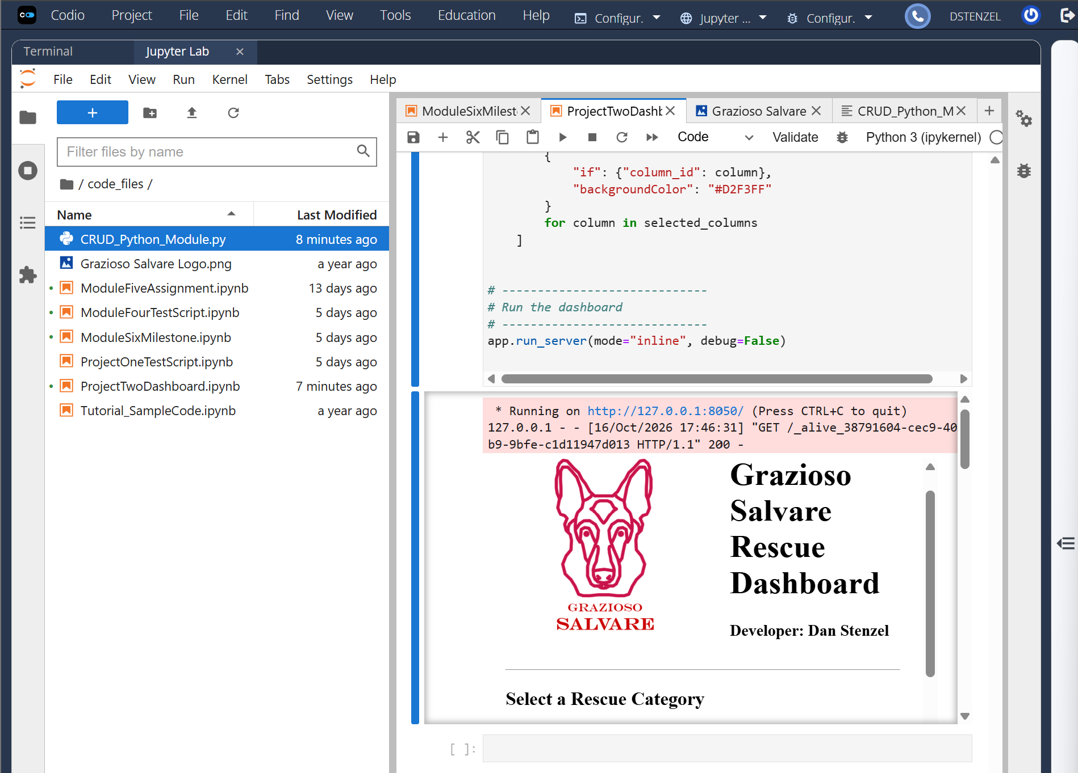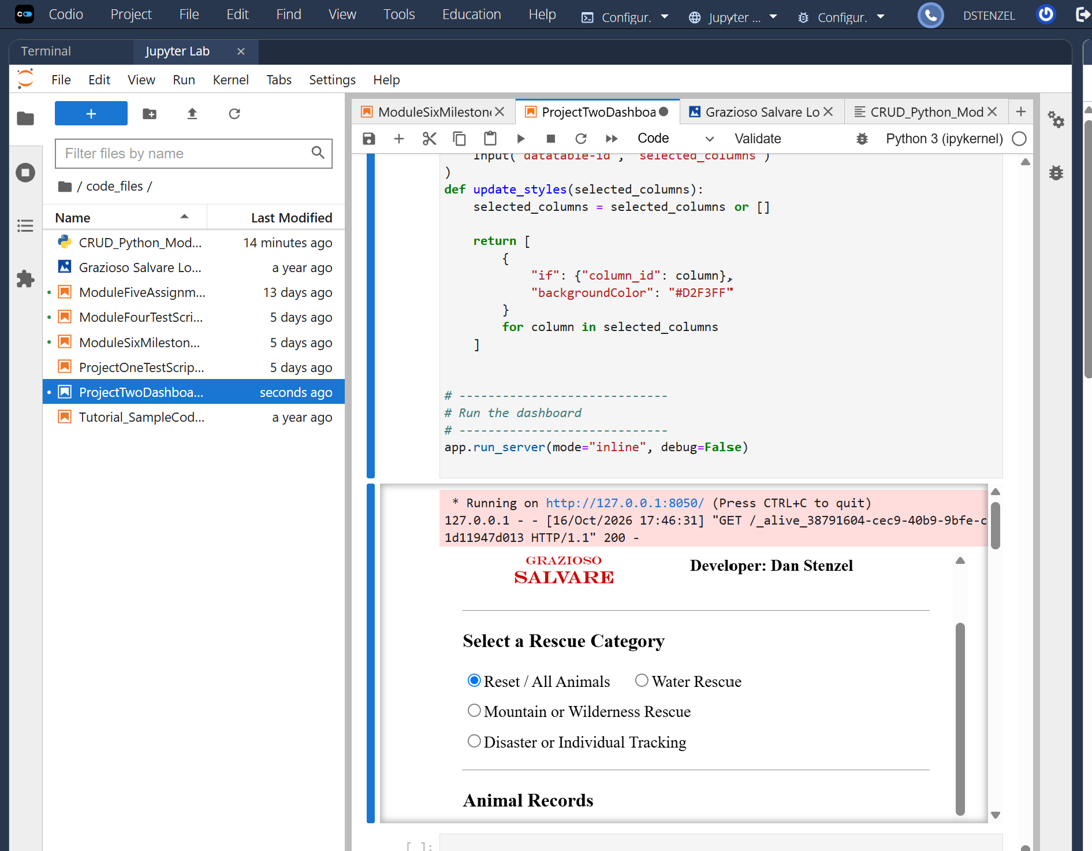

Figure 2. Water Rescue

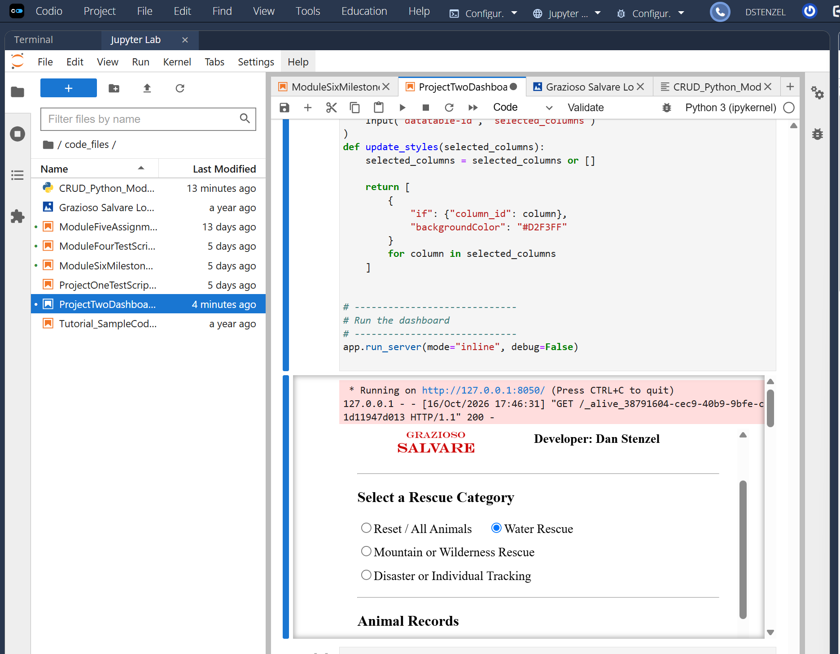

Figure 3. Mountain or Wilderness Rescue

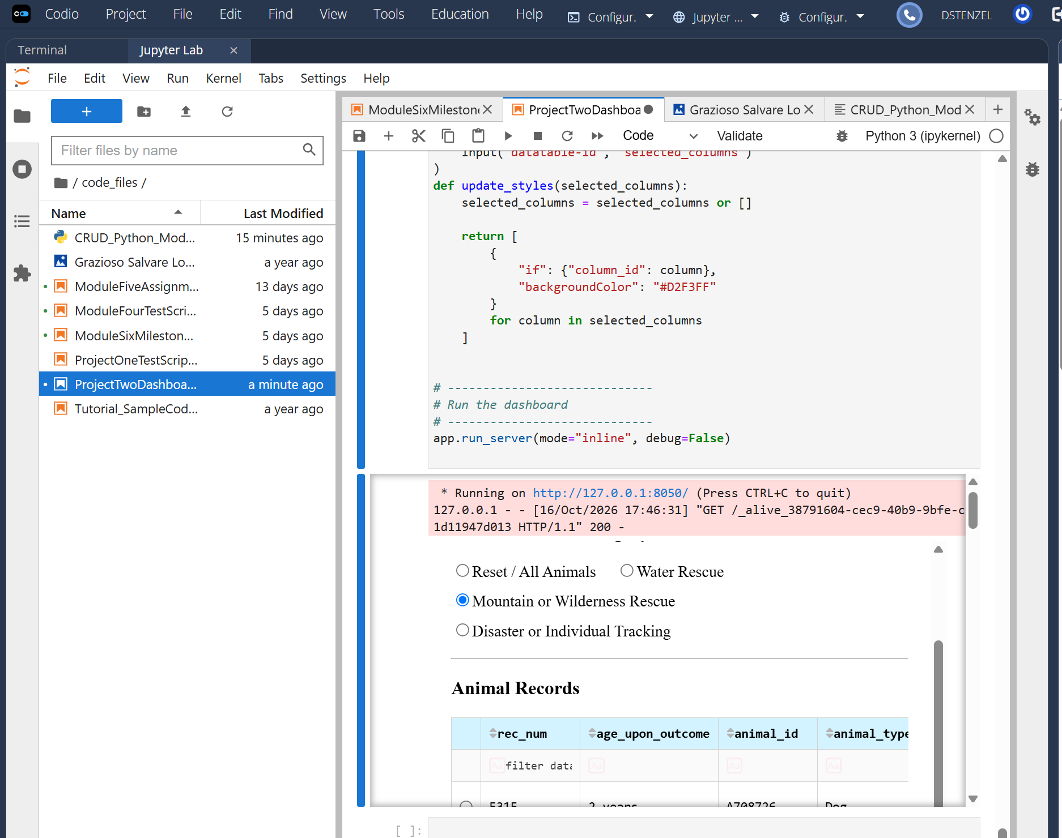

Figure 4. Disaster or Individual Tracking

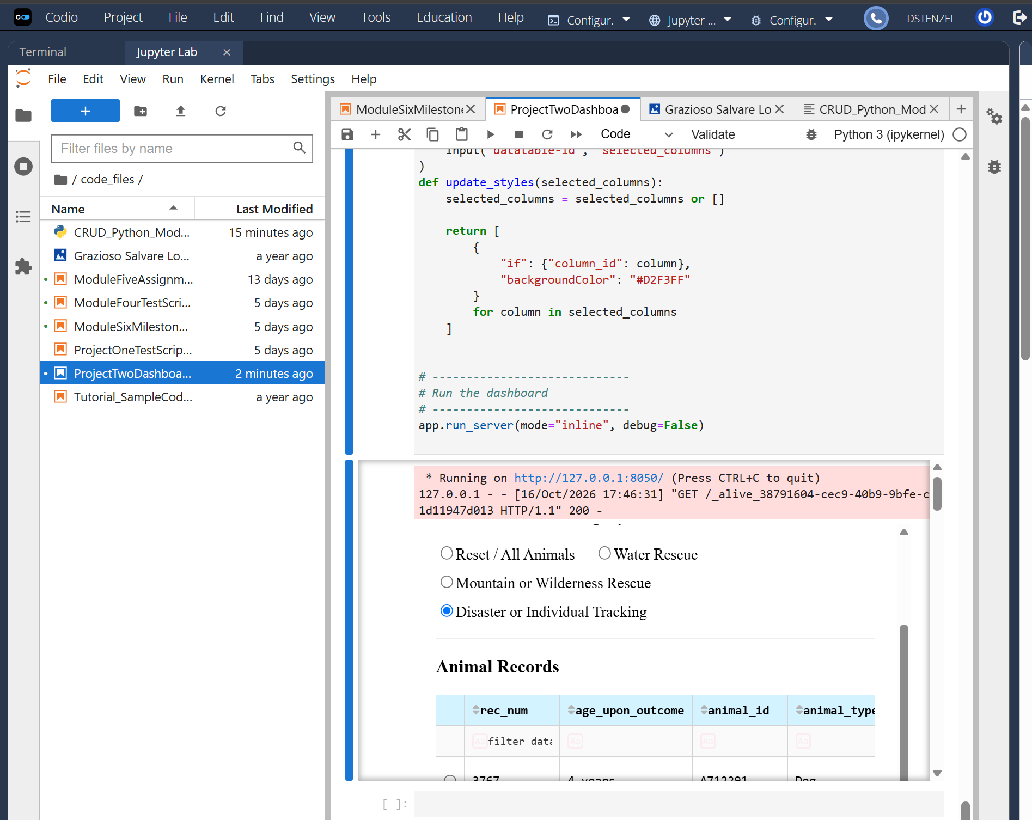

Figure 5. Reset

7. Challenges and Solutions
- CRUD module import error: The first run failed because the CRUD module imported itself, causing a circular import. The self-import line was removed from CRUD_Python_Module.py, while the import remained in the dashboard notebook.
- Completing dashboard callbacks: The starter notebook contained unfinished filter and chart callbacks. These were completed so the selected rescue category queries MongoDB and the resulting table data drives the breed chart and geolocation map.
- Database and dataset consistency: The filter queries depend on the dataset using the expected breed, sex, age, and coordinate fields. These field names and the MongoDB account credentials must be kept consistent when reproducing the application.
- Map responsiveness: The map uses animal latitude and longitude fields to place markers. The implementation limits displayed markers to 500 to help keep the map responsive when many records are returned.

8. Resources
- Dash documentation: https://dash.plotly.com/
- JupyterDash project: https://github.com/plotly/jupyter-dash
- PyMongo documentation: https://pymongo.readthedocs.io/
- MongoDB documentation: https://www.mongodb.com/docs/
- Plotly Express documentation: https://plotly.com/python/plotly-express/
- dash-leaflet documentation: https://www.dash-leaflet.com/
- SNHU: https://www.snhu.edu/

9. Conclusion
The project combines MongoDB data access with a Python dashboard to help users explore animal records for potential rescue-training categories. The interactive filters, table, breed chart, and geolocation map provide a single interface for examining the dataset. Before final submission, add the five actual screenshots and verify that the ZIP contains the notebook, CRUD module, and any required image assets.

